# Lab 2 HTTP

# Objectives

In this lab we will use Wireshark to investigate application layer HTTP protocol, explore several aspects: the basic GET/response interaction, HTTP message formats, retrieving large HTML files, retrieving HTML files with embedded objects, and HTTP authentication and security. Before beginning these labs, you might want to review Section 2.2 of the textbook.[1]

# Procedures

## 1. The Basic HTTP GET/response interaction

In this first task we will employ HTTP protocol to download a very simple HTML file, which is very short, and contains no embedded objects. Do the following:

1. Start up your web browser.
2. Start up the Wireshark packet sniffer, but don’t yet begin packet capture. Enter “http” (just the letters, not the quotation marks) in the display-filter-specification window and press enter, so that only captured HTTP messages will be displayed later in the packet-listing window. (We’re only interested in the HTTP protocol here, and declutter all other uninteresting captured packets).
3. Wait a bit more than one minute (we’ll see why shortly), and then begin Wireshark packet capture.
4. Surf website http://gaia.cs.umass.edu/wireshark-labs/HTTP-wireshark-file1.html in your browser
5. Your browser should display a very simple, one-line HTML file.
6. Stop Wireshark packet capture.

Your Wireshark window should look similar to the window shown in Figure 1.

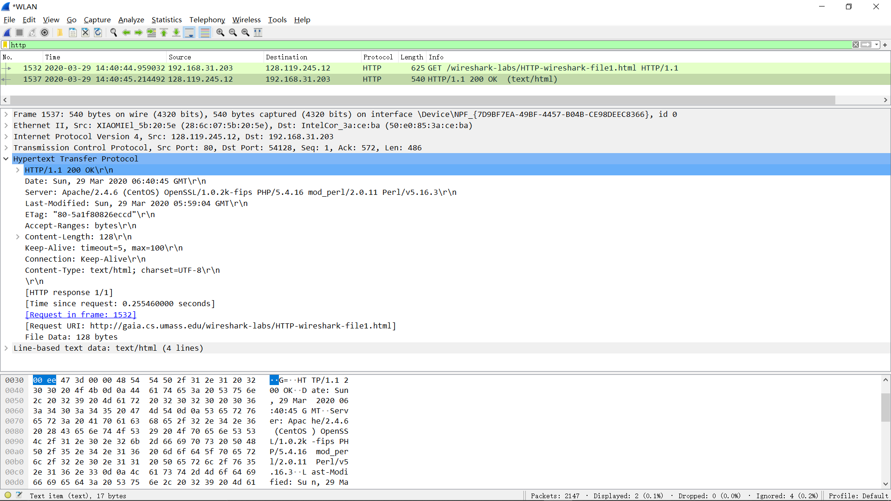

**Figure 1:** Wireshark Display after http://gaia.cs.umass.edu/wireshark-labs/ HTTP-wireshark-file1.html has been retrieved by your browser

The example in Figure 1 shows in the packet-listing window that two HTTP messages were captured: the GET message (from your browser to the gaia.cs.umass.edu web server) and the response message from the server to your browser. The packet-contents window shows details of the selected message (in this case the HTTP OK message, which is highlighted in the packet-listing window). Recall that since the HTTP message was carried inside a TCP segment, which was carried inside an IP datagram, which was carried within an Ethernet frame, Wireshark displays the Frame, Ethernet, IP, and TCP packet information as well. We want to minimize the amount of non-HTTP data displayed (we’re interested in HTTP here, and will be investigating these other protocols is later labs), so make sure the boxes at the far left of the Frame, Ethernet, IP and TCP information have a right-pointing triangle (which means there is hidden, un-displayed information), and the HTTP line has a down-pointing triangle (which means that all information about the HTTP message is displayed).

(*Note:* You should ignore any HTTP GET and response for favicon.ico. If you see a reference to this file, it is your browser automatically asking the server if it (the server) has a small icon file that should be displayed next to the displayed URL in your browser. We’ll ignore references to this pesky file in this lab.).

By looking at the information in the HTTP GET and response messages, answer the following questions. When answering the following questions, you should print out the GET and response messages to a pdf file (see the last lab class for an explanation of how to do this) and indicate where in the message you’ve found the information that answers the following questions. In your lab report, annotate the output so that it’s clear where in the output you’re getting the information for your answer (e.g., annotate with text in a colored font).

1. Is your browser running HTTP version 1.0 or 1.1? What version of HTTP is the server running? **My browser is running HTTP version 1.1 and the server is also running on HTTP version 1.1**

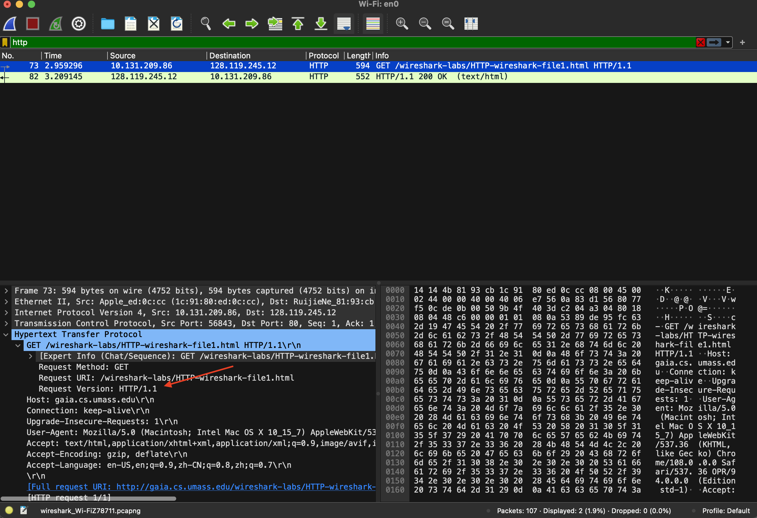

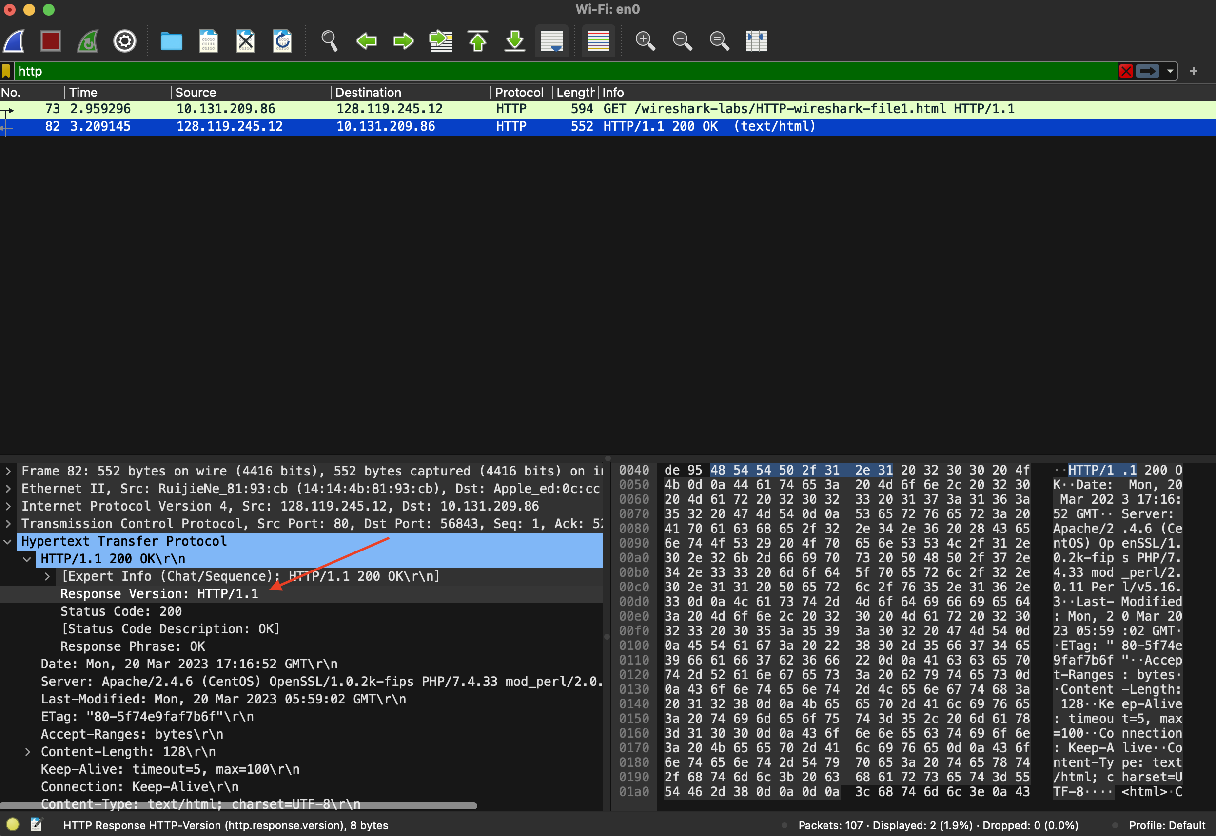

1. What languages (if any) does your browser indicate that it can accept to the server?

**It accepts English (en-US) and Chinese (zh-CN).**

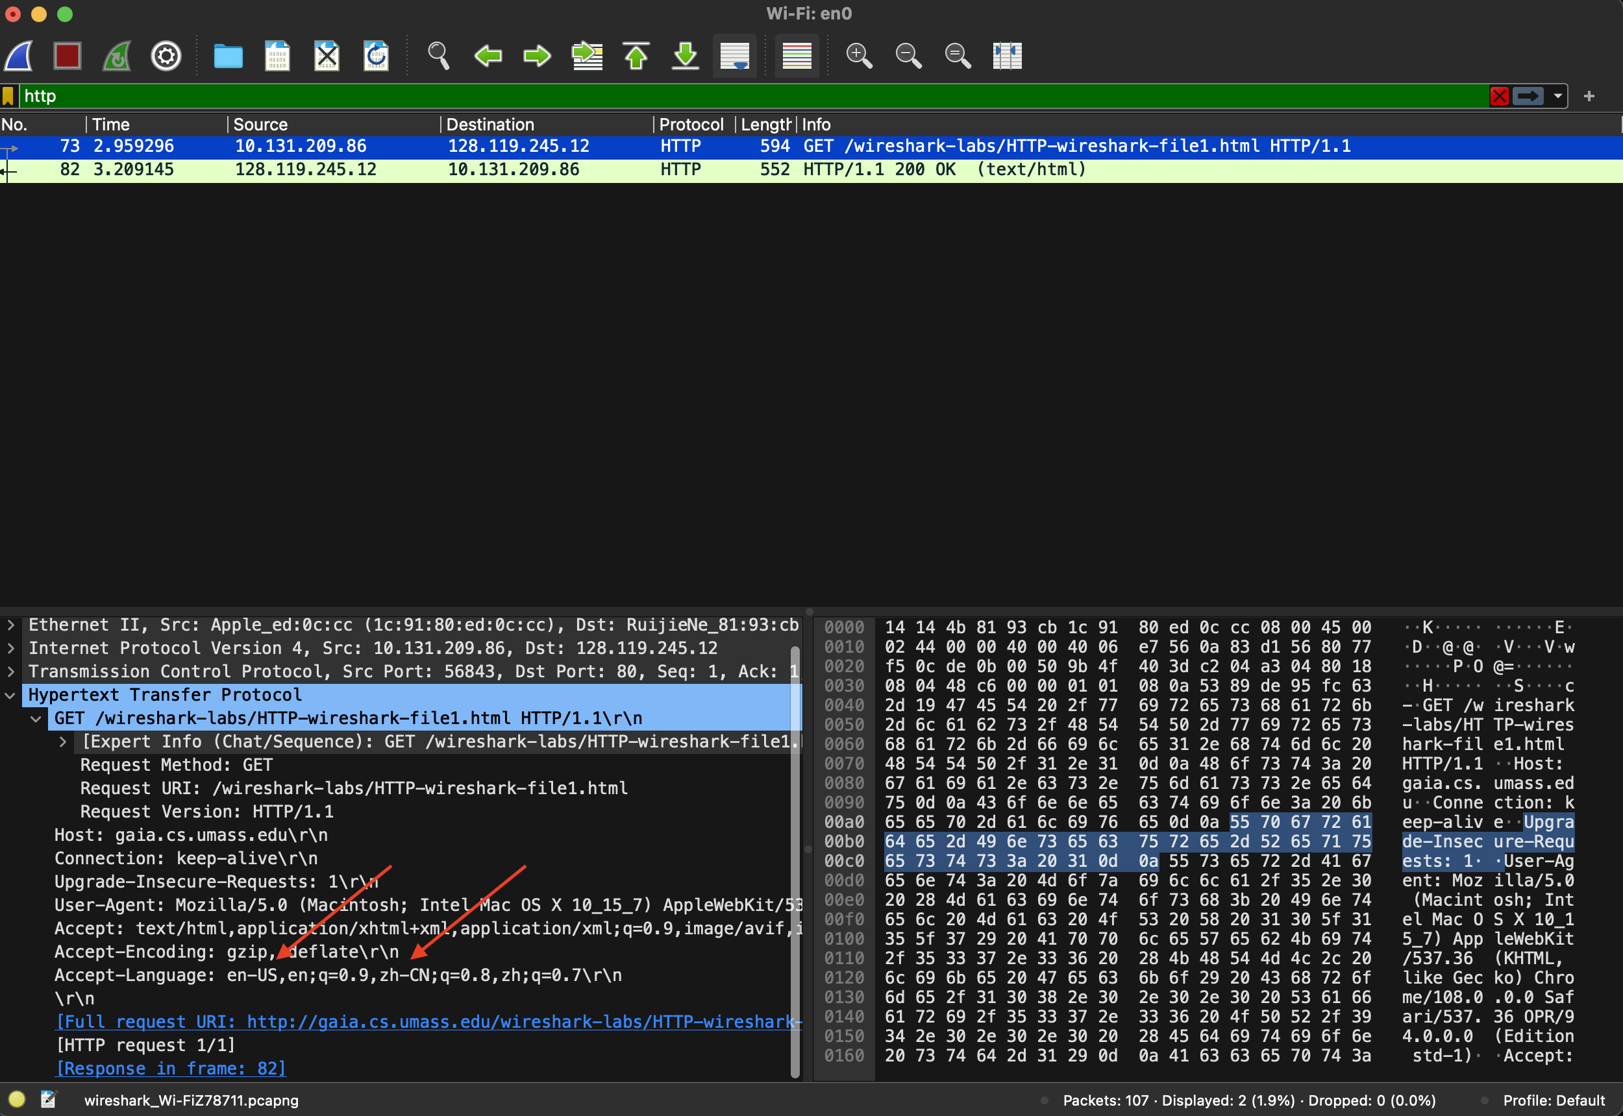

1. What is the IP address of your computer? Of the gaia.cs.umass.edu server?

**The IP address of my computer is 10.131.209.86 and the IP address of gaia.cs.umass.edu server is 128.119.245.12.**

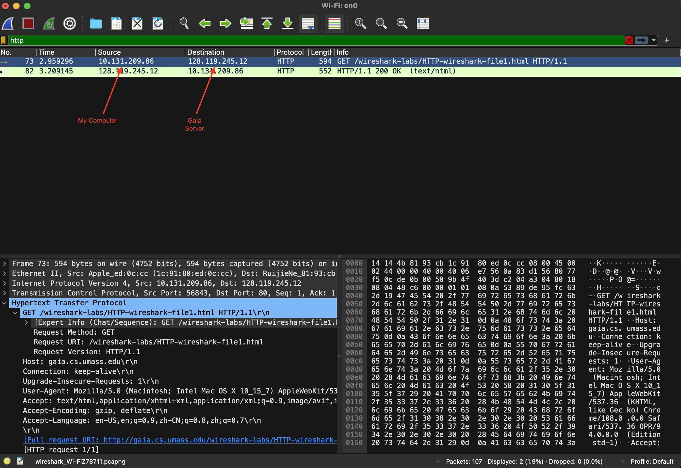

1. What is the status code returned from the server to your browser?

**The status code returned from the server to the browser was 200 (OK).**

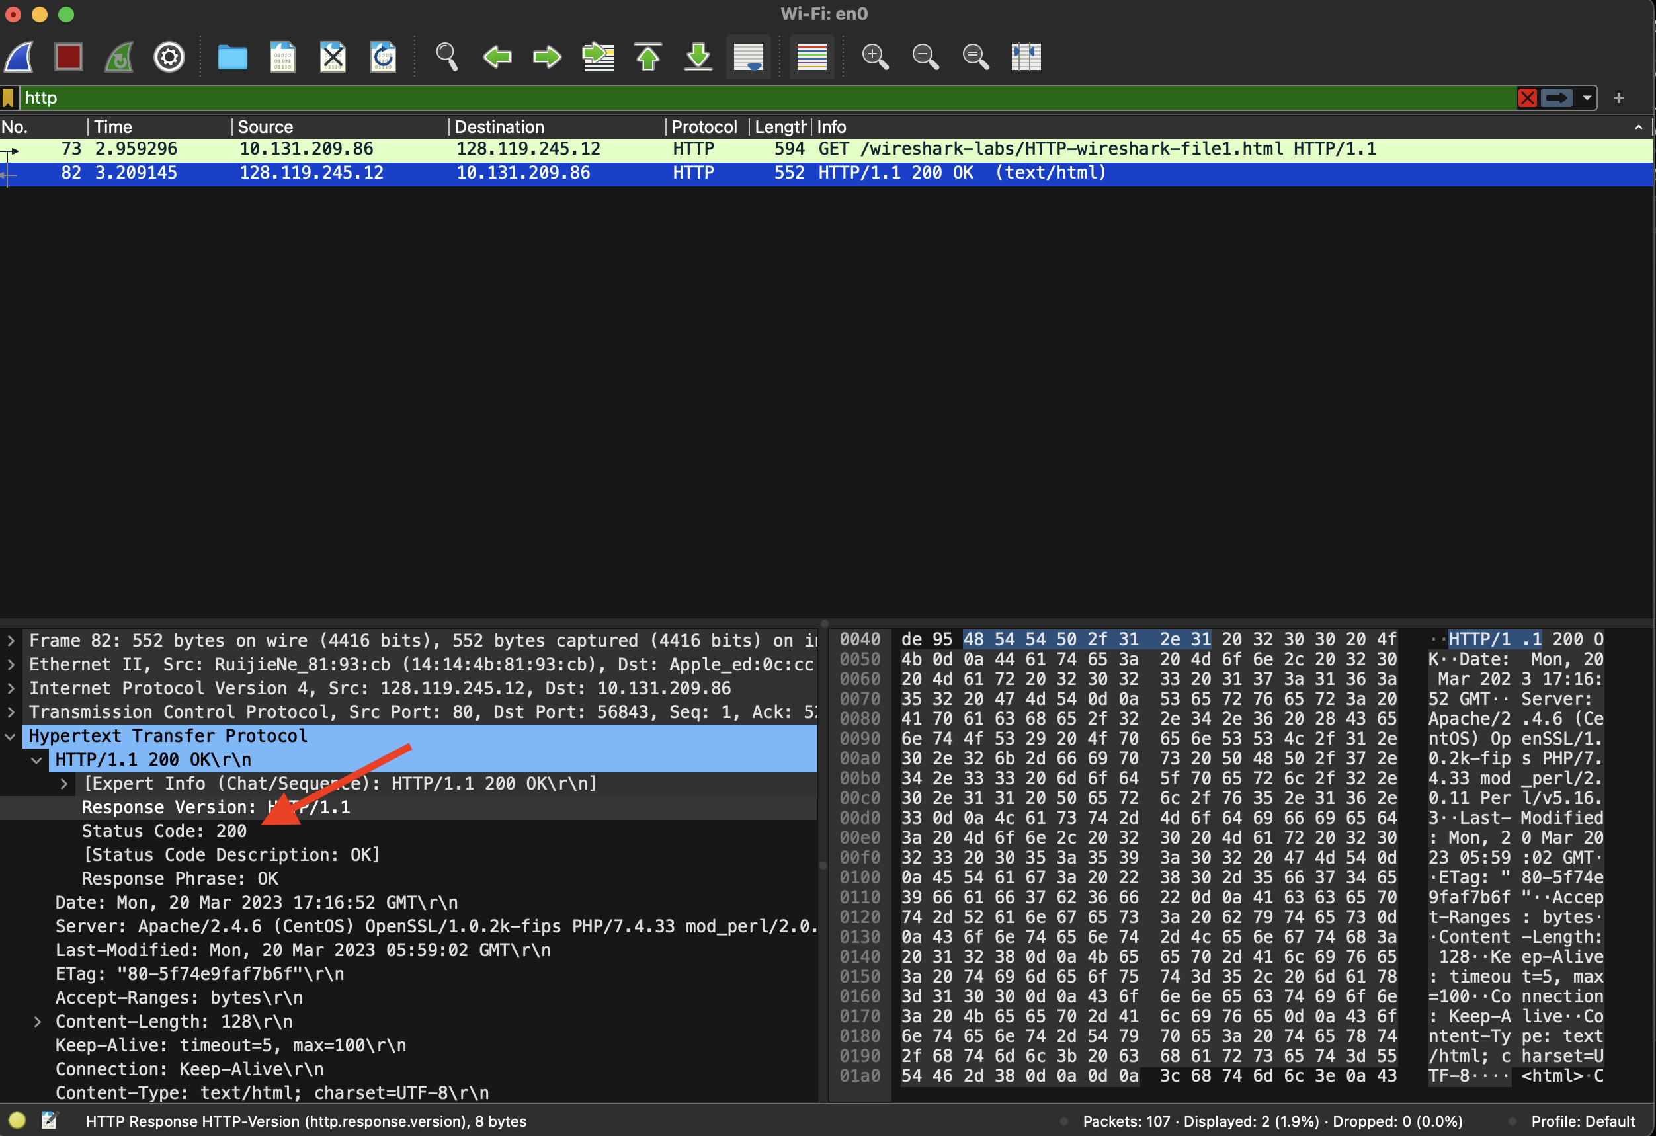

1. When was the HTML file that you are retrieving last modified at the server?

**The HTML file was last modified on Monday, March 20 2023 05:59:02 GMT.**

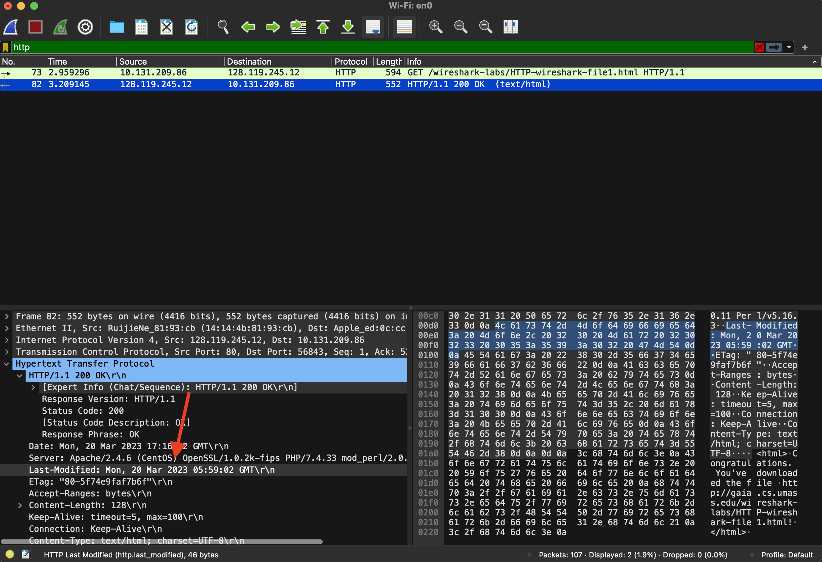

1. How many bytes of content are being returned to your browser?

**128 bytes are being returned to my browser.**

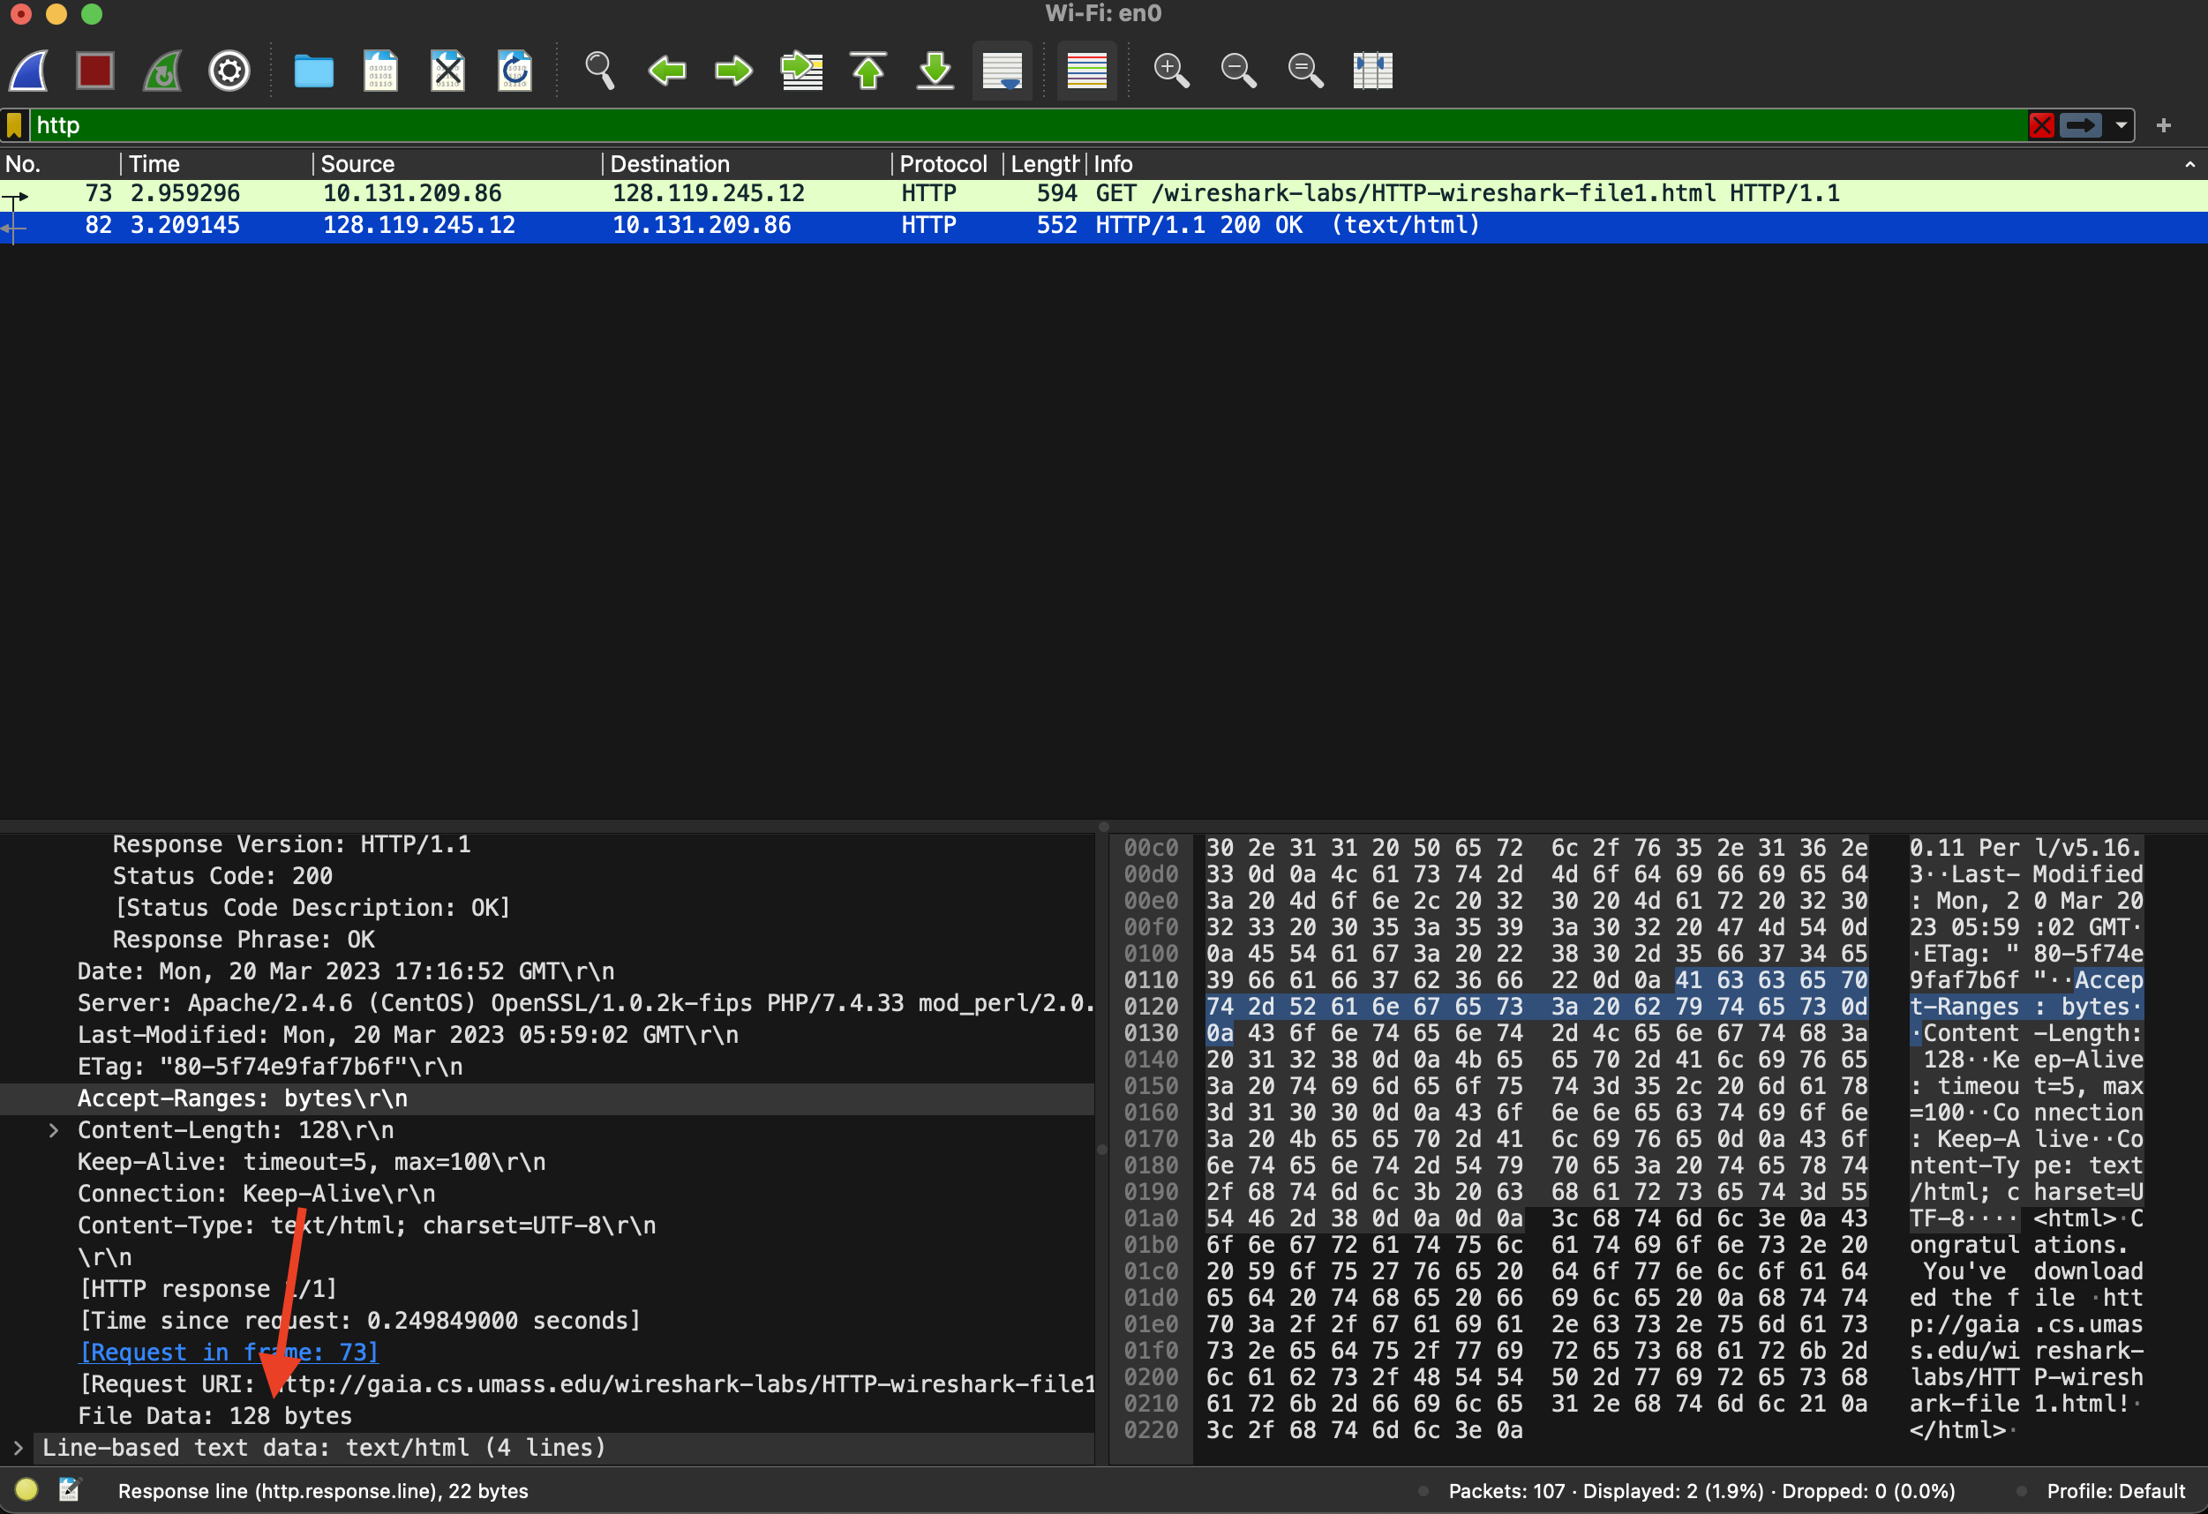

1. By inspecting the raw data in the packet content window, do you see any headers within the data that are not displayed in the packet-listing window? If so, name one.

**Referer- tells the server where the requested URL came from. It will almost always be another URL, or else empty for a direct request (for example, the requester typed the URL into a browser address bar).**

In your answer to question 5 above, you might have been surprised to find that the document you just retrieved was last modified within a minute before you downloaded the document. That’s because (for this particular file), the gaia.cs.umass.edu server is setting the file’s last-modified time to be the current time, and is doing so once per minute. Thus, if you wait a minute between accesses, the file will appear to have been recently modified, and hence your browser will download a “new” copy of the document.

## 2. The HTTP CONDITIONAL GET/response interaction

Recall from Section 2.2.5 of the text, that most web browsers perform object caching and thus perform a conditional GET when retrieving an HTTP object. Before performing the steps below, make sure your browser’s cache is empty. (To do this under chrome, select *History->**Clear browsing data*, or for Internet Explorer, select *Tools->Internet Options->Delete File;* these actions will remove cached files from your browser’s cache.) Now do the following:

* Start up your web browser, and make sure your browser’s cache is cleared, as discussed above.
* Start up the Wireshark packet sniffer
* Enter the following URL into your browser  
  http://gaia.cs.umass.edu/wireshark-labs/HTTP-wireshark-file2.html  
  Your browser should display a very simple five-line HTML file.
* Quickly enter the same URL into your browser again (or simply select the refresh button on your browser)
* Stop Wireshark packet capture, and enter “http” in the display-filter-specification window, so that only captured HTTP messages will be displayed later in the packet-listing window.

Answer the following questions:

1. Inspect the contents of the first HTTP GET request from your browser to the server. Do you see an “IF-MODIFIED-SINCE” line in the HTTP GET?

**No**

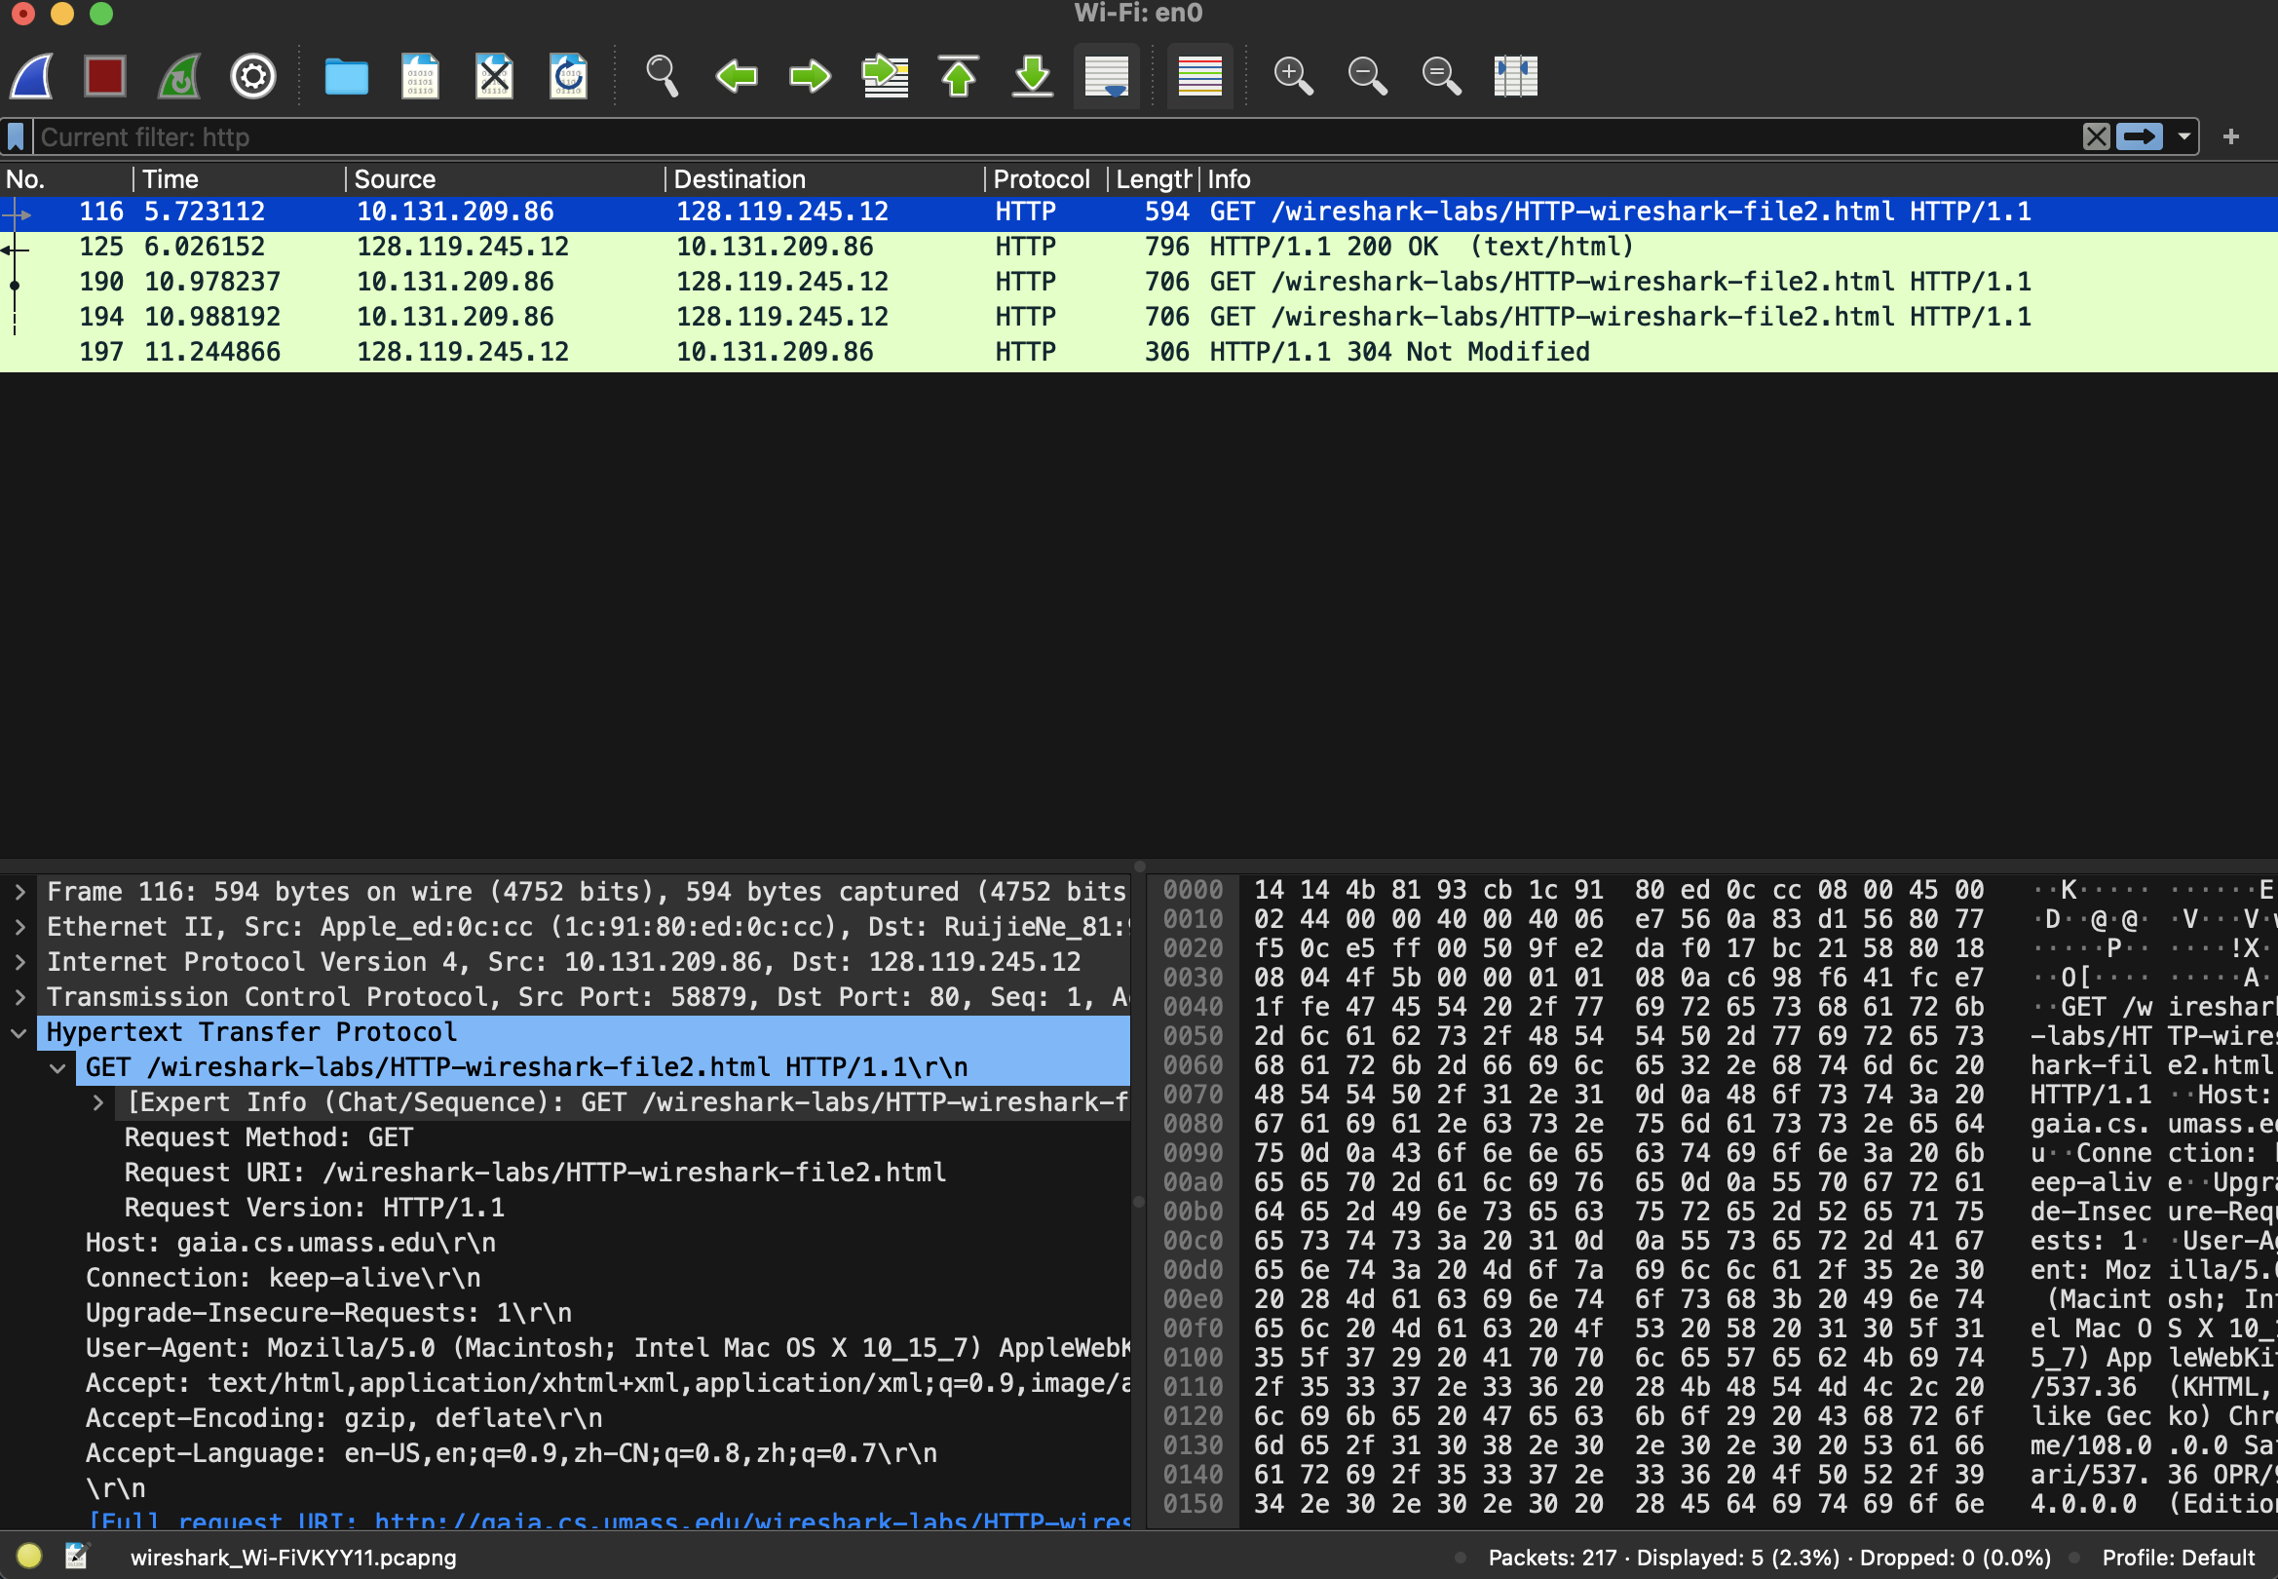

1. Inspect the contents of the server response. Did the server explicitly return the contents of the file? How can you tell?

**Yes, I can tell by checking the line-based text data section that the content of the website was returned.**

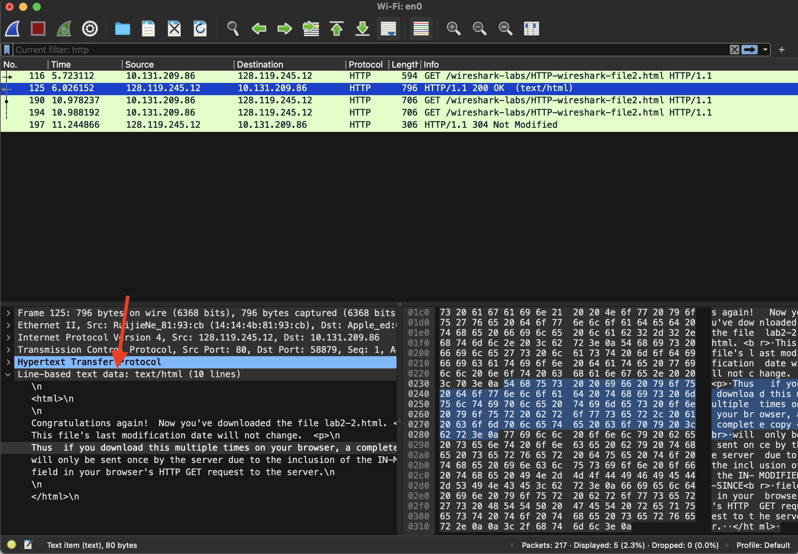

1. Now inspect the contents of the second HTTP GET request from your browser to the server. Do you see an “IF-MODIFIED-SINCE:” line in the HTTP GET? If so, what information follows the “IF-MODIFIED-SINCE:” header?

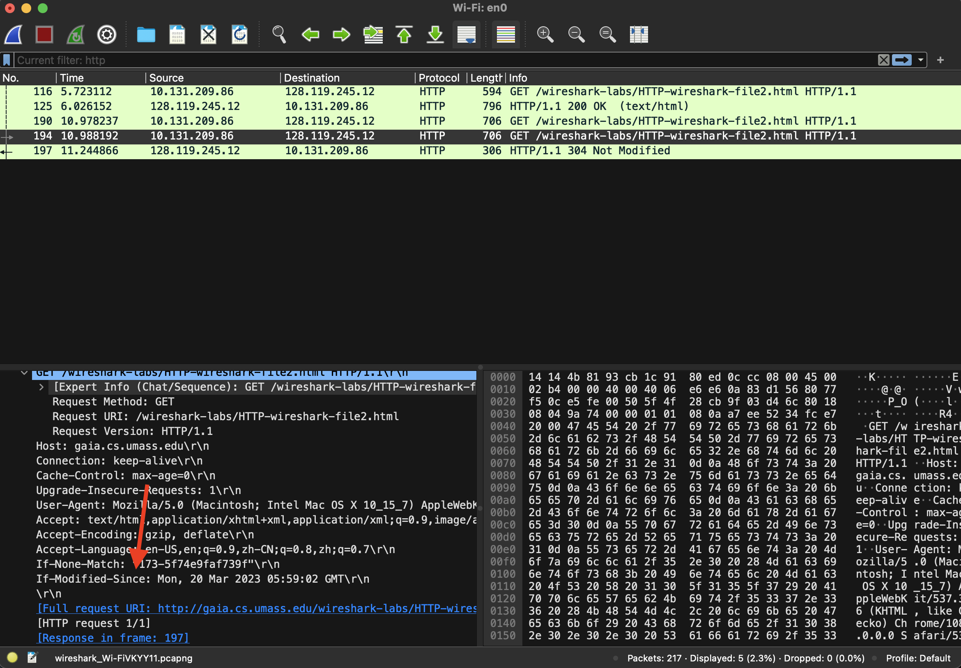

**The “IF-MODIFIED-SINCE:” header shows Mon, 20 Mar 2023 05:59:02 GMT\r\n**

1. What is the HTTP status code and phrase returned from the server in response to this second HTTP GET? Did the server explicitly return the contents of the file? Explain.

**The HTTP status code was 304 and phrase was “Not Modified”. The server did not explicitly return the contents of the file. This is because the contents were received from the cache which hadn’t been modified.**

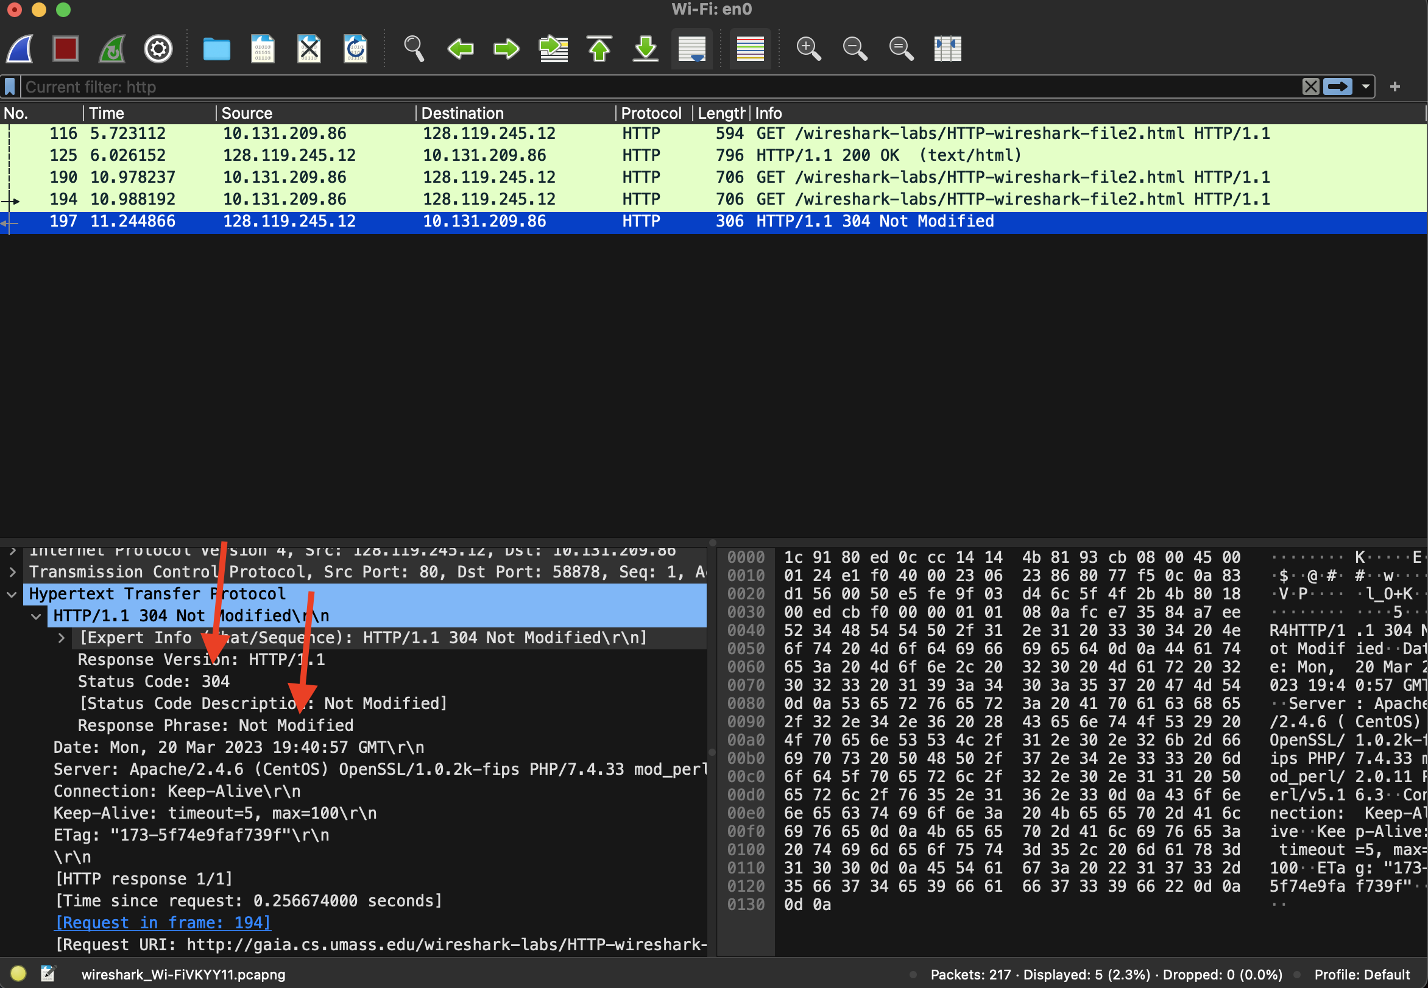

## 3. Retrieving Long Documents

In our examples thus far, the documents retrieved have been simple and short HTML files. Let’s next see what happens when we download a long HTML file. Do the following:

* Start up your web browser, and make sure your browser’s cache is cleared, as discussed above.
* Start up the Wireshark packet sniffer
* Enter the following URL into your browser  
  http://gaia.cs.umass.edu/wireshark-labs/HTTP-wireshark-file3.html  
  Your browser should display the rather lengthy US Bill of Rights.
* Stop Wireshark packet capture, and enter “http” in the display-filter-specification window, so that only captured HTTP messages will be displayed.

In the packet-listing window, you should see your HTTP GET message, followed by a multiple-packet TCP response to your HTTP GET request. This multiple-packet response deserves a bit of explanation. Recall from Section 2.2 (see Figure 2.9 in the text) that the HTTP response message consists of a status line, followed by header lines, followed by a blank line, followed by the entity body. In the case of our HTTP GET, the entity body in the response is the *entire* requested HTML file. In our case here, the HTML file is rather long, and at 4500 bytes is too large to fit in one TCP packet. The single HTTP response message is thus broken into several pieces by TCP, with each piece being contained within a separate TCP segment (see Figure 1.24 in the textbook). Wireshark indicates each TCP segment as a separate packet, and the fact that the single HTTP response was fragmented across multiple TCP packets is indicated by the “TCP segment of a reassembled PDU” in the Info column of the Wireshark display. Some versions of Wireshark used the “Continuation” phrase to indicated that the entire content of an HTTP message was broken across multiple TCP segments. We stress here that there is no “Continuation” message in HTTP!

Answer the following questions in your lab report:

1. How many HTTP GET request messages did your browser send? Which packet number in the trace contains the GET message for the Bill or Rights?

**The browser sent 1 HTTP GET request message (excluding the favicon.ico GET request). The packet number in the trace that contained the GET message for the Bill of Rights was #120.**

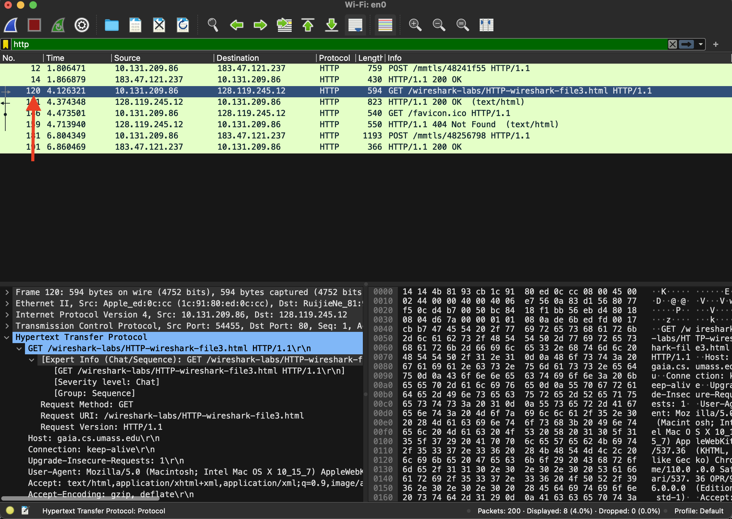

1. Which packet number in the trace contains the status code and phrase associated with the response to the HTTP GET request?

**The packet #131 contains the status code and phrase associated with the response to the HTTP GET request.**

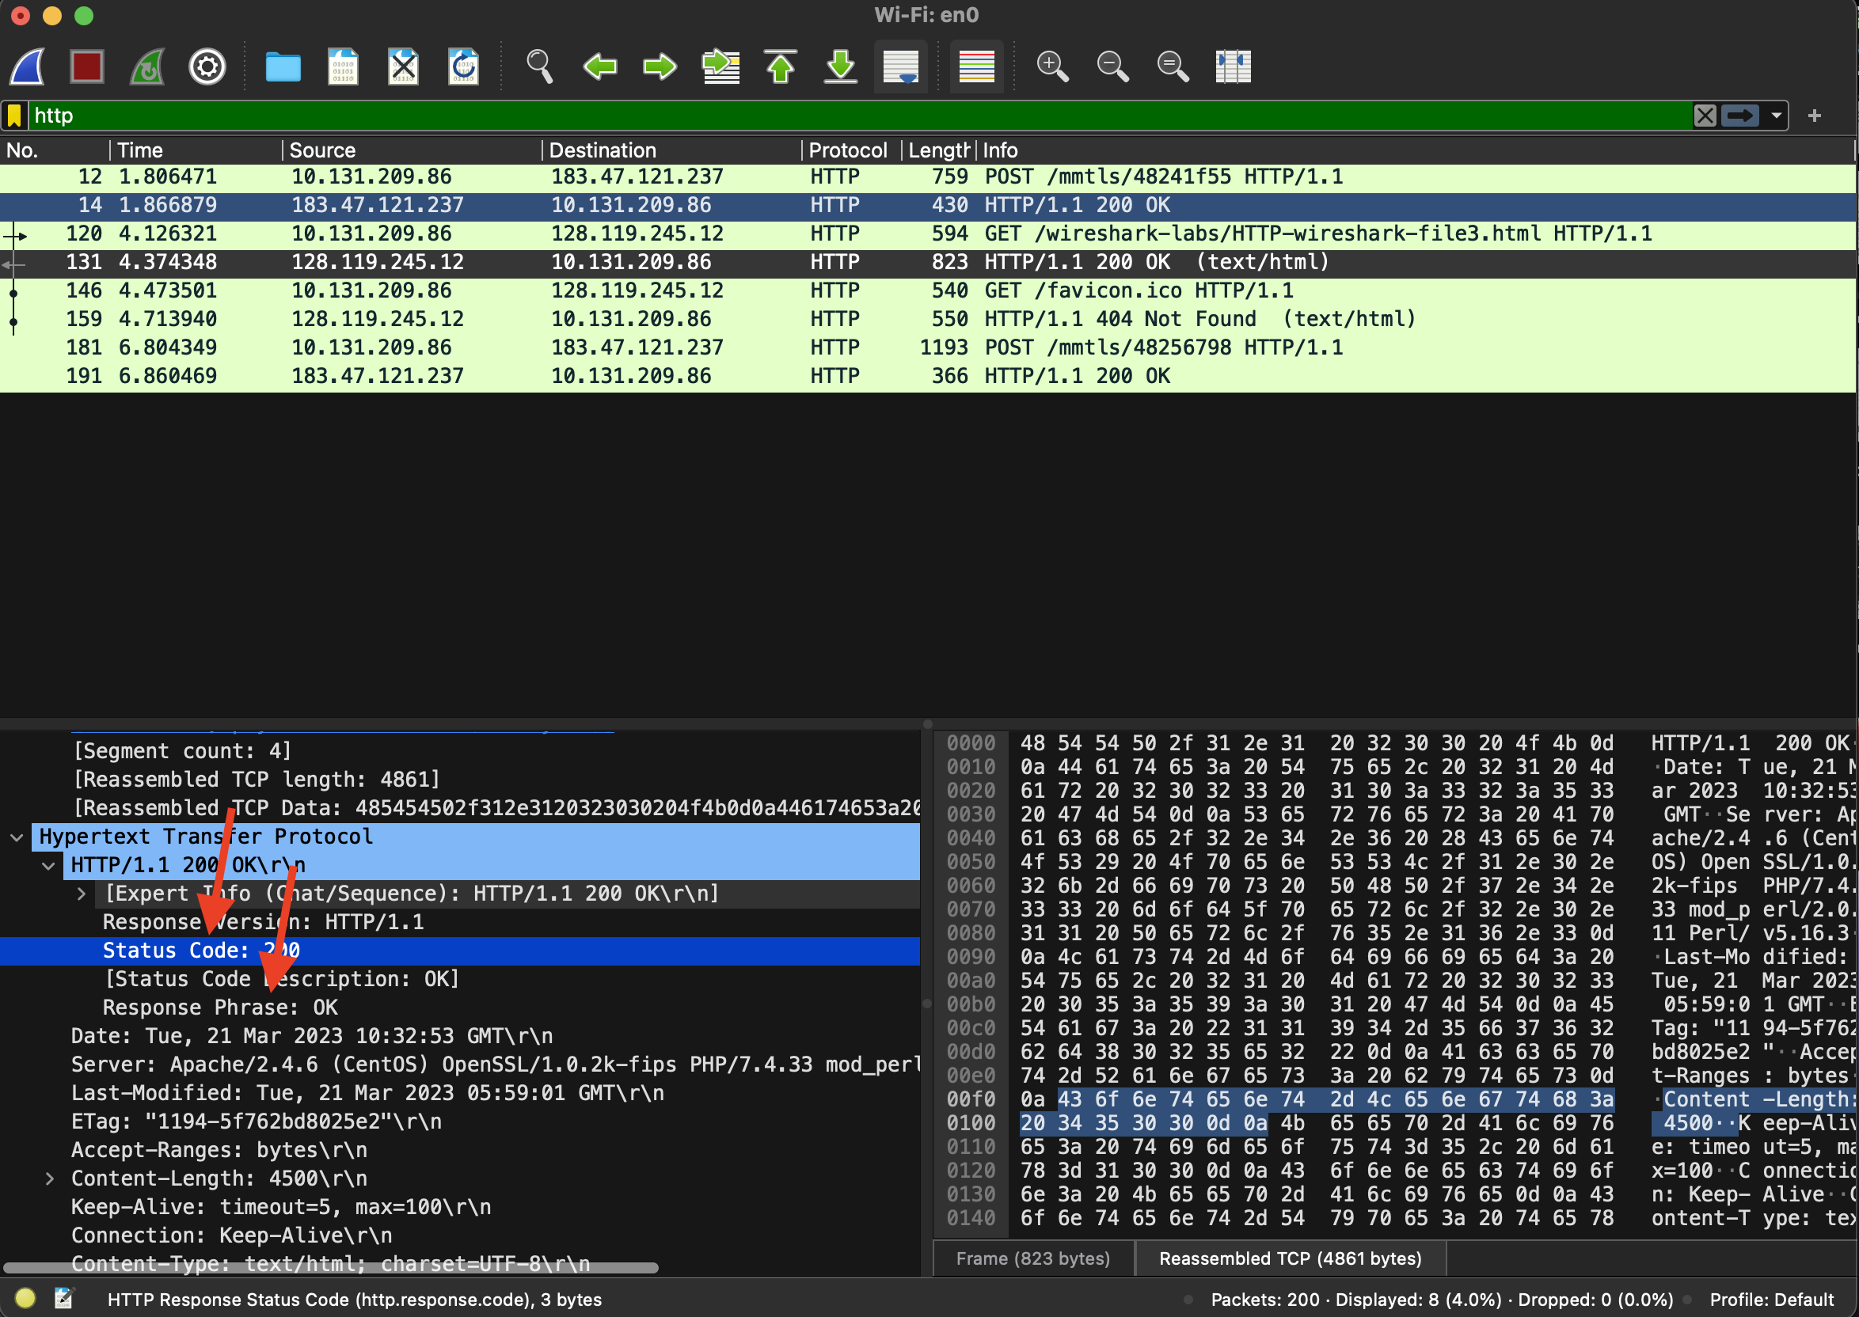

1. What is the status code and phrase in the response?

**The status code is 200 and the phrase in the response is OK.**

1. How many data-containing TCP segments were needed to carry the single HTTP response and the text of the Bill of Rights?

**4 Reassembled TCP segments (4861 bytes): #128 (1368), #129 (1368), #130 (1368), #131(757).**

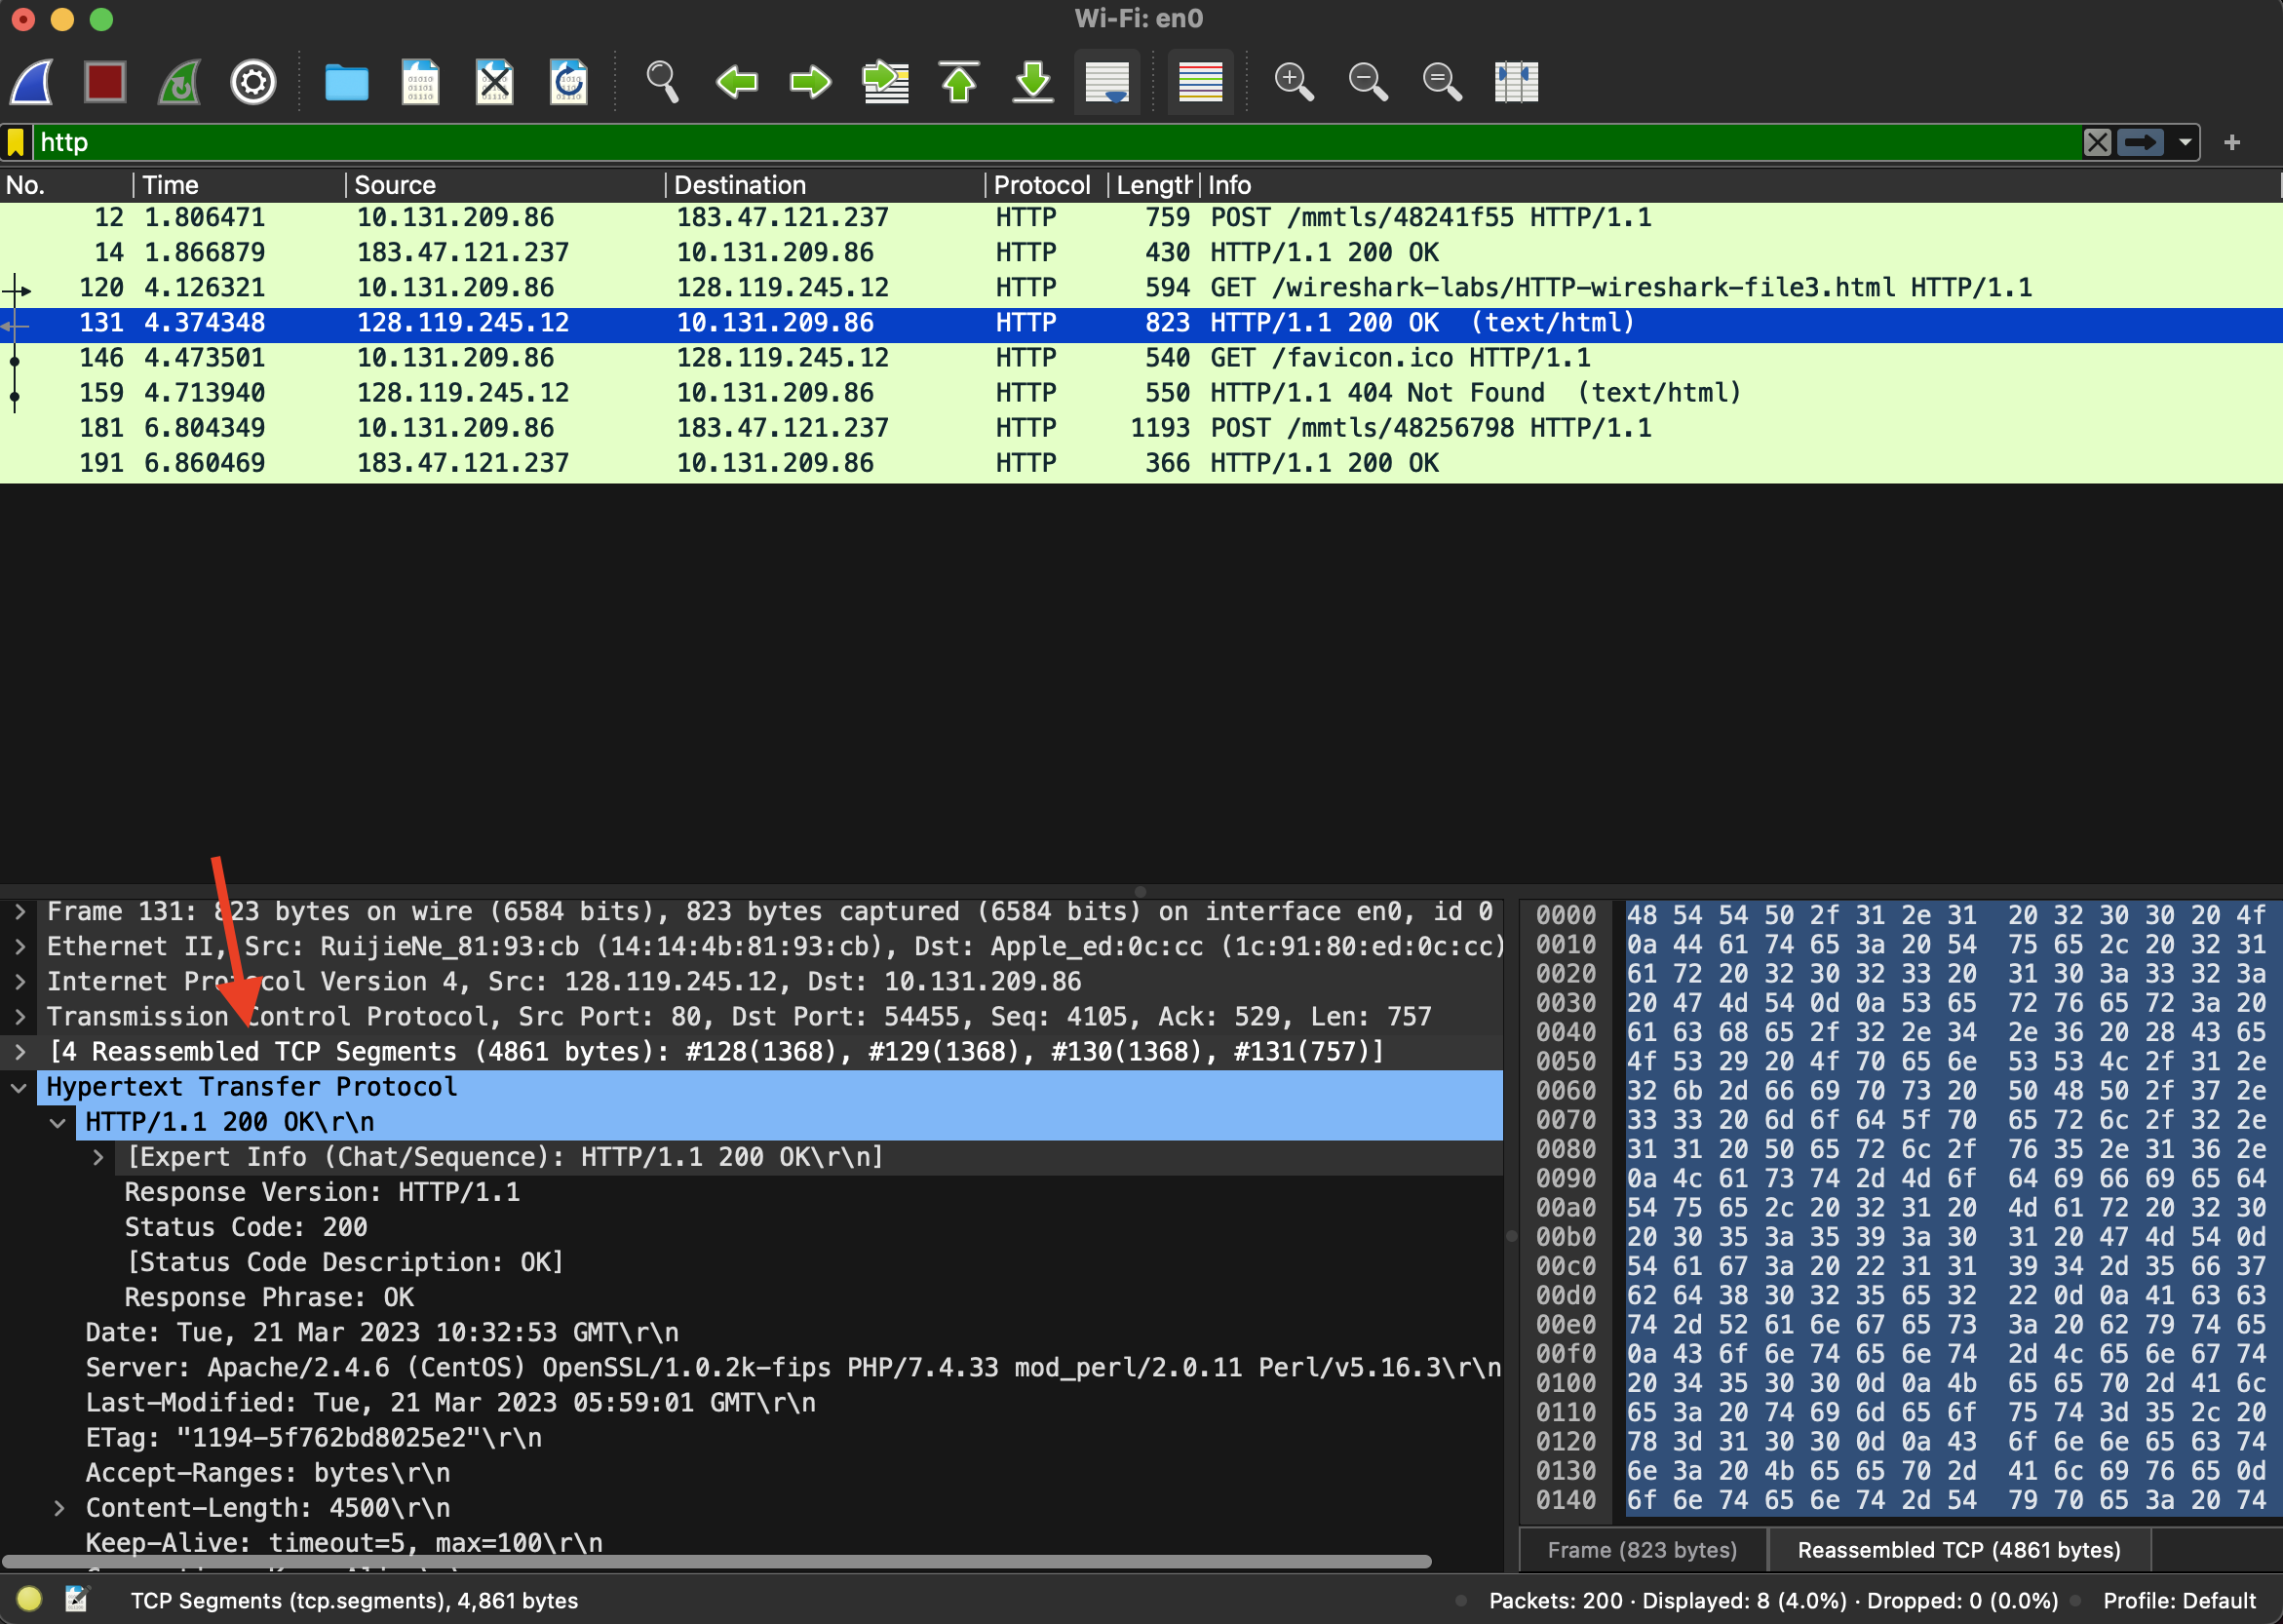

## 4. HTML Documents with Embedded Objects

Now that we’ve seen how Wireshark displays the captured packet traffic for large HTML files, we can look at what happens when your browser downloads a file with embedded objects, i.e., a file that includes other objects (in the example below, image files) that are stored on another server(s).

Do the following:

* Start up your web browser, and make sure your browser’s cache is cleared, as discussed above.
* Start up the Wireshark packet sniffer
* Enter the following URL into your browser  
  http://gaia.cs.umass.edu/wireshark-labs/HTTP-wireshark-file4.html  
  Your browser should display a short HTML file with two images. These two images are referenced in the base HTML file. That is, the images themselves are not contained in the HTML; instead the URLs for the images are contained in the downloaded HTML file. As discussed in the textbook, your browser will have to retrieve these logos from the indicated web sites. The textbook publisher’s logo is retrieved from the gaia.cs.umass.edu web site. The image of the cover for the 5th edition of the textbook is stored at the caite.cs.umass.edu server. (These are two different web servers inside cs.umass.edu).
* Stop Wireshark packet capture, and enter “http” in the display-filter-specification window, so that only captured HTTP messages will be displayed.

Answer the following questions in your lab report:

1. How many HTTP GET request messages did your browser send? To which Internet addresses were these GET requests sent?

**My browser sent 3 HTTP GET request messages. Two of the HTTP GET requests were sent to 128.119.245.12 and one was sent to 178.79.137.164.**

1. Can you tell whether your browser downloaded the two images serially, or whether they were downloaded from the two web sites in parallel? Explain.

**By checking the HTTP GET request and response TCP source and destination ports, I can see if our files were downloaded serially or in parallel. In my case, the 2 images were transmitted over 2 TCP connections therefore they were downloaded serially.**

5. HTTP Authentication

Finally, let’s try visiting a web site that is password-protected and examine the sequence of HTTP message exchanged for such a site. The URL

http://gaia.cs.umass.edu/wireshark-labs/protected_pages/HTTP-wireshark-file5.html is password protected. The username is “wireshark-students” (without the quotes), and the password is “network” (again, without the quotes). So let’s access this “secure” password-protected site. Do the following:

* Make sure your browser’s cache is cleared, and close down your browser. Then, start up your browser
* Start up the Wireshark packet sniffer
* Enter the following URL into your browser  
  http://gaia.cs.umass.edu/wireshark-labs/protected_pages/HTTP-wireshark-file5.html  
  Type the requested user name and password into the pop up box.
* Stop Wireshark packet capture, and enter “http” in the display-filter-specification window, so that only captured HTTP messages will be displayed later in the packet-listing window.

Now let’s examine the Wireshark output. You might want to first read up on HTTP authentication by reviewing the easy-to-read material on “HTTP Access Authentication Framework” at http://frontier.userland.com/stories/storyReader$2159

Answer the following questions in your lab report:

1. What is the server’s response (status code and phrase) in response to the initial HTTP GET message from your browser?

**The server status code for the initial HTTP GET message from my browser was 401 and the phrase was “Unauthorized”.**

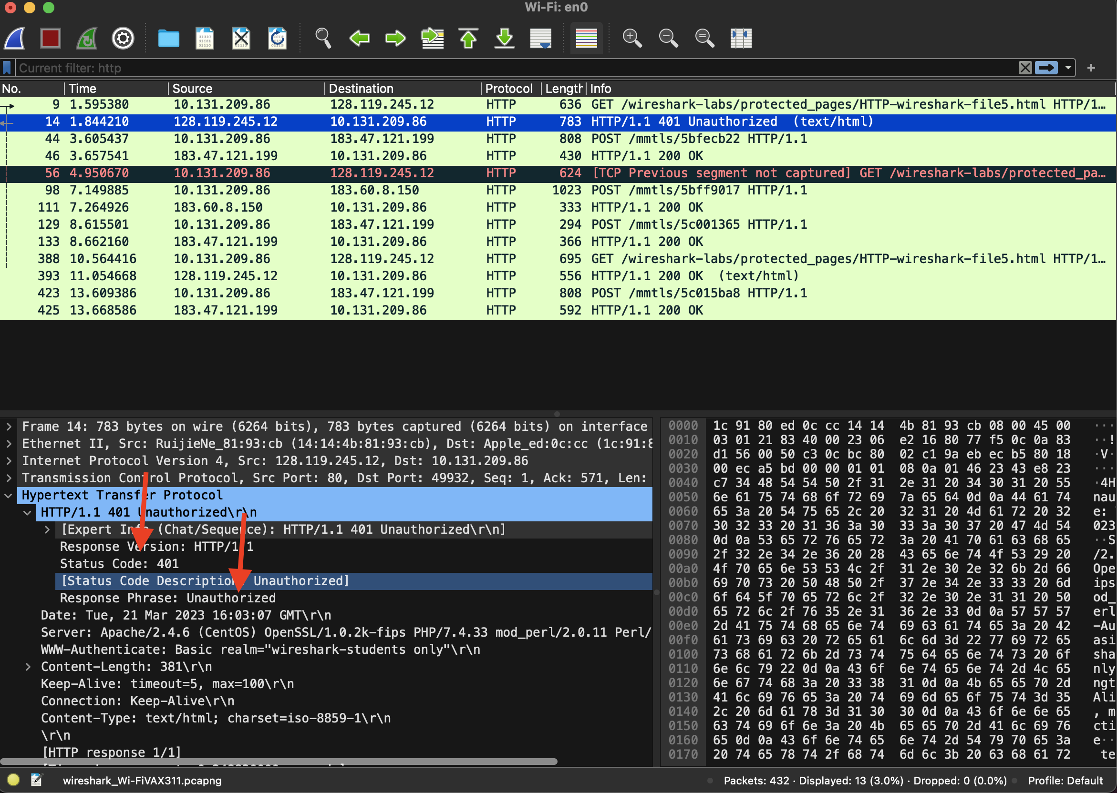

1. When your browser’s sends the HTTP GET message for the second time, what new field is included in the HTTP GET message?

**For the second HTTP GET message, the “Authorization” field was included.**

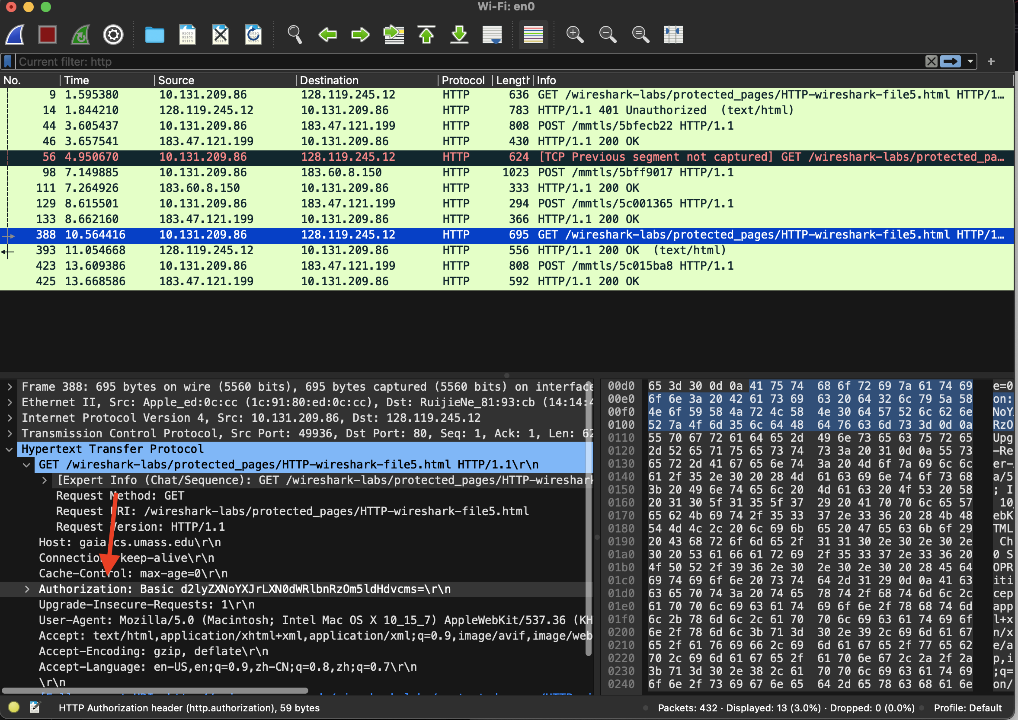

The username (wireshark-students) and password (network) that you entered are encoded in the string of characters (d2lyZXNoYXJrLXN0dWRlbnRzOm5ldHdvcms=) following the “Authorization: Basic” header in the client’s HTTP GET message. While it may appear that your username and password are encrypted, they are simply encoded in a format known as Base64 format. The username and password are *not* encrypted! To see this, go to http://www.motobit.com/util/base64-decoder-encoder.asp and enter the base64-encoded string d2lyZXNoYXJrLXN0dWRlbnRz and decode. *Voila!* You have translated from Base64 encoding to ASCII encoding, and thus should see your username! To view the password, enter the remainder of the string Om5ldHdvcms= and press decode. Since anyone can download a tool like Wireshark and sniff packets (not just their own) passing by their network adaptor, and anyone can translate from Base64 to ASCII (you just did it!), it should be clear to you that simple passwords on WWW sites are not secure unless additional measures are taken.

Fear not! As we will see in Chapter 8 of the textbook, there are ways to make WWW access more secure. However, we’ll clearly need something that goes beyond the basic HTTP authentication framework!

1. References to figures and sections are for the textbook*.*